

Practices for Secure Software Report

Table of Contents
Document Revision History 3
Client 3
Instructions 3
Developer 4
1. Algorithm Cipher 4
2. Certificate Generation 4
3. Deploy Cipher 4
4. Secure Communications 4
5. Secondary Testing 4
6. Functional Testing 4
7. Summary 4
8. Industry Standard Best Practices 4

Document Revision History

Version | Date | Author | Comments
1.0 | 8/14/2026 | Erik Hays | Initial Report

Client



Developer
Erik Hays

Algorithm Cipher

The algorithm we chose for this application, given the security considerations, is SHA-256. This cipher is appropriate for a financial institution because of its track record, adoptability and relative performance. While it is large enough to be computationally infeasible to brute-force, it is also fast enough to deploy at scale.

SHA-256 works by dividing the data up into 512-bit blocks and then processing these blocks through a series of 64 rounds of computational procedures. Through these, the original data is manipulated by a set of bitwise operations that transform the data in a way that is deterministic but practically impossible to reverse. The output generated by SHA-256 is always a uniform 256 bits long, typically represented as a 64-character hexadecimal string. This string is essentially a digital fingerprint of the original data—each one is unique.

Random numbers also play a big role in secure digital communications. Many cryptographic libraries come with tools to generate random numbers. While a truly “random” number is challenging to produce using modern computers, many of these tools rely on external sources of entropy to act as a seed that can be used to achieve true randomization. Random numbers have applications in authentication, encryption and blockchain technologies.

While SHA is great for one-way encryption in the form of generating a unique hash, it does not solve the problem of unencrypting data once it has been transmitted. This is where symmetric/asymmetric key-pair technologies come into play. Using shared sets of keys between the server and end-user, data can be encrypted before transit and then reversed once it arrives using the same key. Symmetric key encryption is faster, but much less secure, while asymmetric key encryption is highly secure but computationally expensive. Most modern security tools use a combination of these approaches to ensure fast and effective encryption.

The current state of digital security and the threat landscape is always evolving. A number of encryption algorithms have been recently deprecated due to advances in computing. For example, SHA-1 and MD-5 hashing functions have been disallowed by the National Institute of Standards and Technology (NIST) because researchers have found a way to produce the same hash output using different inputs. This undermines the entire purpose of cryptographic hash functions. Additionally, researchers are currently seeking new approaches to protect against the advent of quantum computing. Once quantum computing becomes mainstream, the fear is that many of today’s algorithms will become vulnerable to the computational power that quantum computing promises.

Certificate Generation

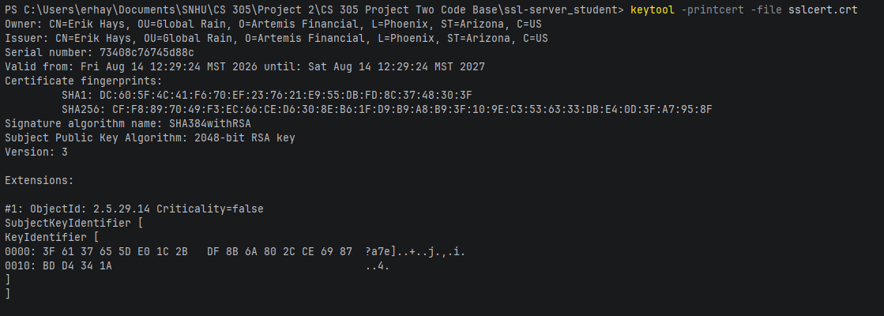

Deploy Cipher

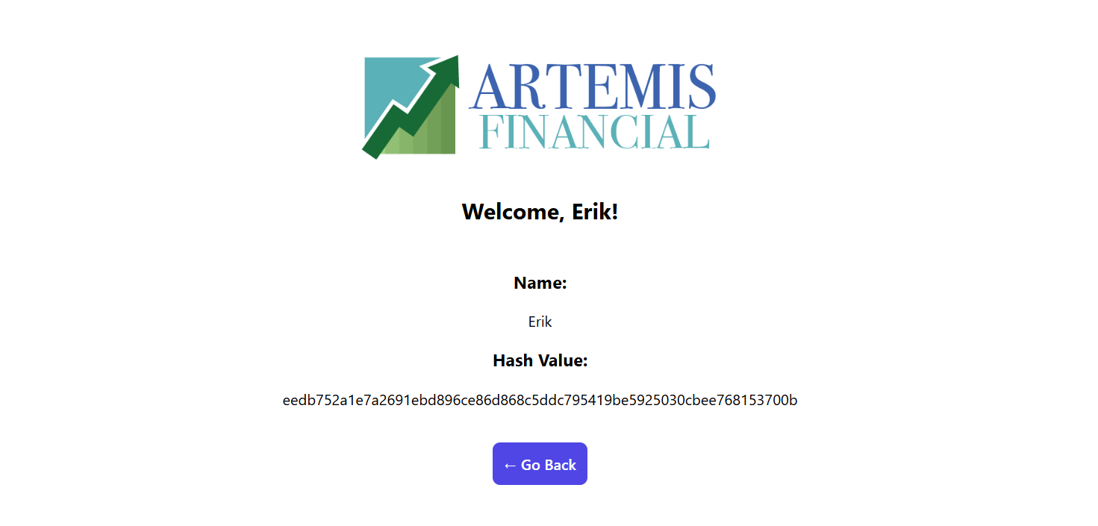

Secure Communications

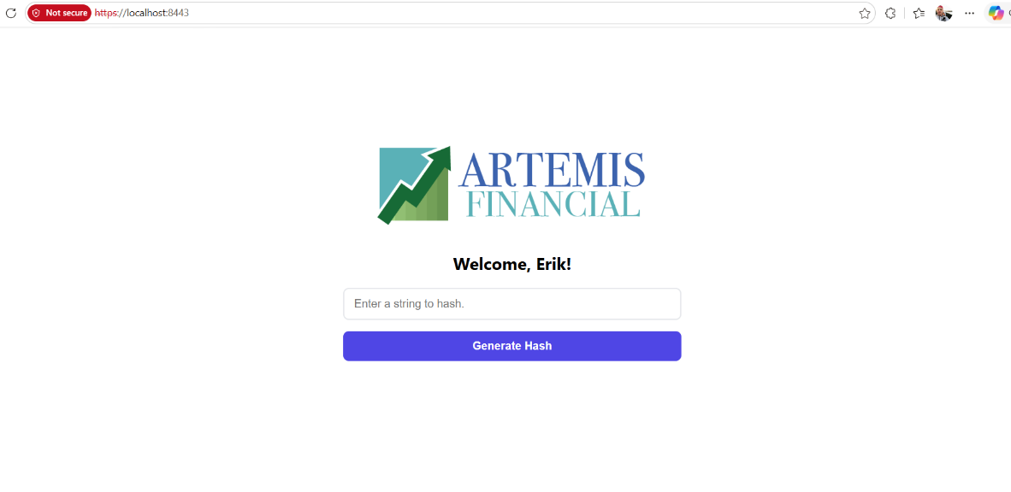

Secondary Testing
Insert screenshots below of the refactored code executed without errors and the dependency-check report.

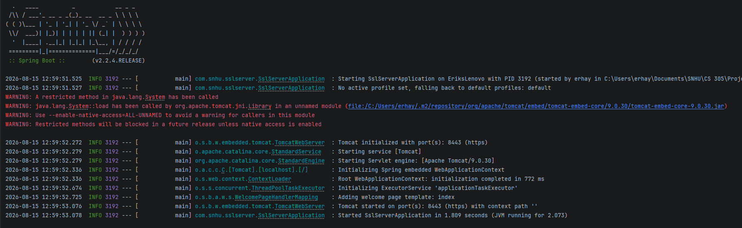

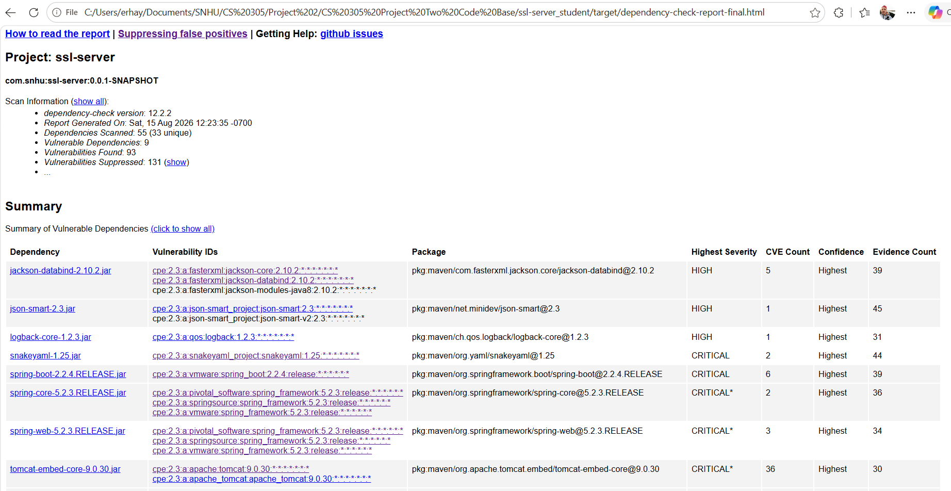

Functional Testing



This screenshot shows the application presenting the user with a generic error message upon throwing an exception. This is the exact functionality we designed in order to prevent the user from potentially seeing a full stack trace when encountering an error. During functional testing of the application software, we analyzed its syntactical, logical and general security vulnerabilities. Below you will find a summary of each.

- Syntactical

After running a Linter across the entire application codebase, a number of syntactical issues were identified. First, there were some constants declared without using the Java convention of all uppercase letters separated by underscores. Secondly, the scan flagged the “index” string literal used multiple times and suggested that it be hardcoded as a constant itself. The scan also suggested that we create custom exception classes, rather than just using the generic RuntimeException(). Finally, a few minor HTML issues were uncovered in the index template file. Each of these issues were addressed and the Linter came back clean.

- Logical

Upon manual functional review, all logical vulnerabilities are properly addressed. Modularity, encapsulation, error handling and data validation are all present in the software design.

- Overall Security

All of the static and functional testing that we implemented did not uncover any additional security vulnerabilities.

Summary

By refactoring the code, we touched on a number of areas of security outlined in the Vulnerability Assessment Diagram. Input validation is properly implemented. In our sole public POST route, there are checks on null data parameters as well as validation to ensure that a massive string cannot be submitted. The API is secured through the use of HTTP method-specific annotation. Additionally, we locked down Transport Layer Security using a self-signed certificate and forced HTTP to redirect to HTTPS. The cryptography we chose is standard across the financial industry as a hashing tool. TLS uses asymmetric key cryptography to ensure the authentication of the application when users access it. Custom exception classes were implemented and a GlobalExceptionHandler catches all thrown exceptions so that the user will never see any implementation details directly. The only public methods present in the application are the exposed API routes and all local variables are declared with the PRIVATE access modifier.

There are couple items worth noting here that should be addressed before deploying this software. The keystore is currently sitting inside the project repo. Ideally, this file should be moved externally and stored inside an environment variable. While our self-signed certificate is suitable for development, a trusted third-party Certificate Authority should provide the certificate that we use in production. Currently, we have a configuration class that redirects requests sent to the standard HTTP port. However, HTTP should eventually be disabled entirely. And although it is beyond the scope of this project, access controls should be implemented or integrated with Artemis Financial’s existing auth. Finally, because we introduced Thymeleaf as a templating tool to demo this software, we must be careful about remote code execution. Fortunately, Thymeleaf auto-escapes any text rendered through an attribute so this should not be a problem.

Industry Standard Best Practices

Throughout the development of this software, the primary goal was to design a system that satisfied the business requirements while ensuring that the application will remain secure to the many sophisticated threats that exist in the world today. One of the biggest threat vectors today is that of supply-chain attacks or vulnerabilities exploited through third-party tooling. We ran a suite of tests that included: static testing to detect vulnerabilities in our dependencies and functional testing that simulated common user behavior as well as edge cases.

By utilizing our Vulnerability Assessment Process Flow, each component and layer within the application was scrutinized. Any data sent through the public API is properly validated on the server side. This way, common threats such as Remote Code Execution (RCE) and Denial of Service (DoS) attacks will be mitigated. All web traffic is routed through a secure port and encrypted. This prevents attackers from hijacking the session in what’s known as Man in the Middle (MitM) attacks. Secure programming principles such as encapsulation and modularity are present throughout. This defense-in-depth approach ensures that the application is built from the ground up with security in mind and allows for maintainability and extensibility in the future.

